# HOSPITAL PERFORMANCE DASHBOARD

Summary

This hospital performance dashboard provides a comprehensive overview of patient demographics, departmental efficiency, treatment costs, and regional distribution. It captures key metrics such as total patients (1,751), inpatients (1,679), total treatment cost (₹287.6K), and death count (86), offering insights into overall hospital operations. The highest patient volume is seen in the Physical Medicine and Surgery departments, while most patients belong to the 6–20 and 41–60 age groups. Peak hospital activity occurs on Thursdays and Fridays, and nearly 50% of inpatients are from British Columbia. This dashboard enables data-driven decisions through detailed analysis of department-level performance, patient trends, and resource utilization.

**Hospital Overview**:

1.KPI (Key Performance Indicators)

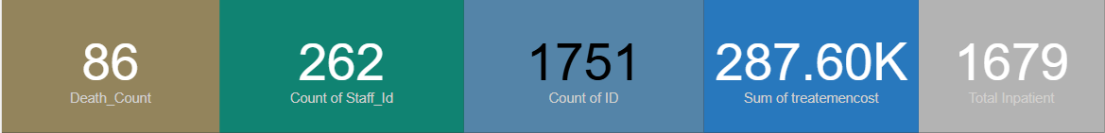

**Key Insights:**

* The hospital has treated a total of **1,751 patients**, with a majority being **inpatients (1,679)**.
* **Total revenue** generated stands at **₹287.6K**, indicating strong financial performance.
* A **death count of 86** suggests a **mortality rate of approximately 4.9%**, highlighting the need to monitor critical cases closely.
* The **staff count is 54**, which may be lean relative to patient volume.

**Recommendations:**

* **Assess and optimize staffing levels** to ensure quality care, especially in high-load departments.
* **Review critical care protocols** and post-discharge processes to help reduce the mortality rate.
* **Regularly track these KPIs over time** to identify trends and make timely operational decisions.
* **Align resources and budgeting** based on revenue and patient volume patterns to improve efficiency.

2. Total patient by Age Bucket

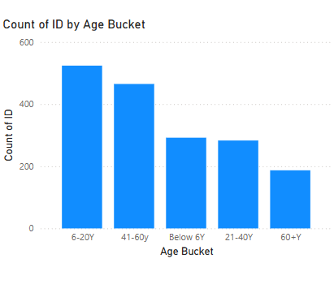-

**Key Insight:** The majority of patients fall within the **6–20** and **41–60** age buckets, indicating that both younger and middle-aged groups are the most frequent users of hospital services. The **0–5** and **61–80** age groups follow closely, while the number of patients in the **81–100** range is significantly lower.

**Recommendation:**The hospital should focus on **tailored health programs** and awareness initiatives targeting younger and middle-aged populations, such as preventive screenings and lifestyle management services. Simultaneously, pediatric and geriatric care services should be reviewed for capacity and quality, especially given the steady demand in both ends of the age spectrum.

3.Status based on patient

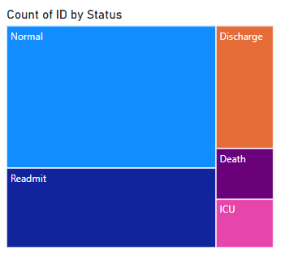

**Key Insight:**  
The Tree Map shows that the majority of patients are categorized as **“Normal”**, followed by a significant portion marked as **“Readmit.”** Smaller yet notable sections include patients in **“ICU”** and **“Death”** statuses. This distribution suggests that while most patients are discharged without complications, a considerable number are returning for additional care, and a small but critical segment requires intensive care.

**Recommendation:**  
The hospital should **analyze readmission cases** to identify common causes and implement follow-up or discharge improvement protocols. Enhanced monitoring and care coordination could reduce unnecessary readmissions. Additionally, reviewing **ICU and death cases** for trends or warning signs could help strengthen emergency response systems and improve critical care outcomes.

4.In Patient and Outpatient by Weekday Name

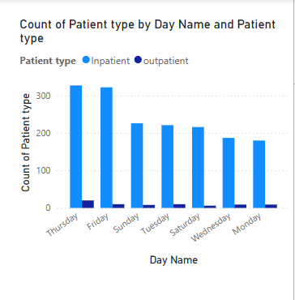

**Key Insight:**  
The chart reveals that **Thursdays and Fridays consistently see higher patient volumes**, particularly among **Inpatients**, while the number of **Outpatients** remains comparatively stable across all weekdays. This indicates a peak in hospital utilization toward the end of the workweek, which may relate to scheduling preferences or referral timings.

**Recommendation:**  
To manage these peak days efficiently, the hospital should **reallocate staff and resources strategically** on Thursdays and Fridays. Increasing outpatient support earlier in the week may also help **distribute patient flow more evenly**, reducing pressure on inpatient services and improving overall care quality and wait times

# **Department Analysis**:

5.The number of patients handled department-wise

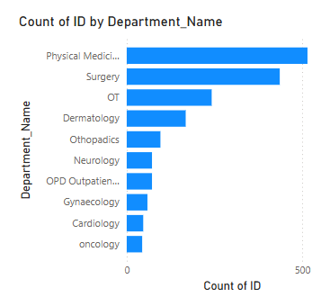

**Key Insight:**  
The data indicates that departments like **Physical Medicine**, **Surgery**, and **Operation Theatre** handle the **highest number of patients**, showing they are the most utilized services in the hospital. Departments such as **Neurology**, **Gynaecology**, and **Orthopaedics** also see notable patient traffic, while a few departments show relatively lower patient counts.

**Recommendation:**  
The hospital should continue to **invest in high-volume departments** by ensuring adequate staffing, equipment, and space to maintain service quality. For departments with lower patient engagement, it is advisable to **review service offerings**, evaluate patient demand, and consider awareness or referral programs to better balance departmental workload and resource usage.

6. Revenue contribution by department

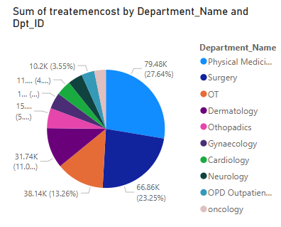

**Key Insight:**  
The analysis shows that departments like **Surgery**, **Operation Theatre**, and **Physical Medicine** contribute the **largest share to overall treatment costs**, indicating they are the primary revenue drivers for the hospital. Meanwhile, departments such as **Gynaecology** and **Neurology** contribute less to total revenue, despite handling a fair number of patients.

**Recommendation:**  
The hospital should regularly **evaluate the pricing and efficiency** of high-revenue departments to ensure sustainability and cost-effectiveness without compromising care quality. For lower-revenue departments, **optimizing service delivery and exploring value-added services** could enhance financial performance. A balanced focus on both clinical outcomes and revenue generation will help ensure long-term operational efficiency.

# **Region Analysis**:

7. Top 8 states by **In-Patient Count**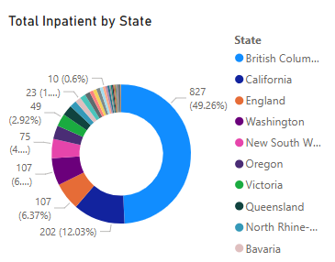

**Key Insight:**  
The donut chart highlights that **British Columbia** accounts for nearly **half of all in-patients**, followed by **California**, **England**, and **New York**. This concentration suggests that a significant portion of the hospital’s inpatient traffic is dependent on just a few states, indicating **strong regional dependence**.

**Recommendation:**  
The hospital should maintain strong relationships and referral networks in high-performing regions like British Columbia while also exploring **expansion opportunities in underrepresented states**. Targeted outreach, local partnerships, or satellite clinics could help **diversify the patient base**, reduce regional risk, and tap into new growth areas.

# **Gender-wise Analysis :**

# 8. Male vs female patients across departments

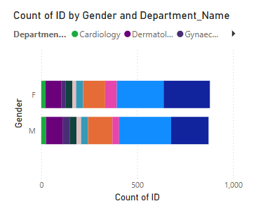

**Key Insight:**  
The analysis shows that **Gynaecology and Dermatology** departments primarily serve **female patients**, while departments like **Orthopaedics and Neurology** have a higher number of **male patients**. Some departments maintain a fairly **balanced gender distribution**, indicating varied service needs across genders.

**Recommendation:**  
The hospital should ensure **gender-specific resource planning** in departments with a strong skew, such as ensuring specialized staff and services for women’s health in Gynaecology. At the same time, it’s important to **promote inclusive care strategies** in all departments to meet the unique health needs of both genders effectively, and regularly monitor gender trends to adjust service delivery accordingly.